Design Development of a Step for Children

Jo HyeonSeong

Graduate School of Dongseo University
Busan, Republic of Korea
eatjo@naver.com

Abstract

The objective of this study is to develop a safe step that grows children’s independence and self-reliance among baby products and is an empirical case research describing the development of step for children by a present firm. This research was conducted in 4 stages: theoretical research, market research and consumer research, design development and selection, and prototype production. This study was performed in-depth for companies to have market competitiveness, and focused on safety as the top priority in design concept as the subject is a child product. It is expected that such empirical case research of design development will directly help people by developing a design.

Keywords: Baby Products, Stool, Business Collavoration, Slip-resistance, fur, Prodouct design development

I. Introduction

A. Background and Objective of Research

According to the ‘2016 Birth Statistics’ by the South Korean National Statistics Office in 2017, the number of babies born in 2016 was 406,200, a decrease by 32,200 babies (7.3%) from the previous year [1]. Despite the lowest birthrate of South Korea in history, the baby product market has had continuous growth. The size of domestic baby products market is about 1.7 trillion KRW, consistently growing by 10% every year [2]. However, the entry of many famous import brands has formed a saturated baby products market, but most baby products only consider the characteristics of young children and have ignored the potential users of products. In response, this study focused on developing a step product among that has different users and purchasers, can cultivate a child’s independence and self-reliance, and that prioritizes on safety the most. Although this study conducted a search using keywords such as ‘step’ or ‘footing for children’ to collect the data of previous research related on young children’s step announced in Korea for literary review, there was no paper releated to search results in Korea. This showed that a step is an item developing young children’s safety and self-reliance and independence among baby products, there is no information on it as a research subject.
In this sense, the value of this study is that it is a pioneer in the field of non-pioneered product design. This study conducted a research and analsyis on the product needs and wants of consumers and users through an in-depth interview, and proposed a marketable product design concept based on this. The proposed design concept, unlike the existing step, aims to reflect users’ convenience and safety and focuses on originality and differentiation so that it can satisfy purchasers’ needs and wants through the development of step design for children.

II. Main Subjects

A. Overview of Step Market Research

The scope and standard of research on the existing step products were set before this study. The scope of research was online market, and produts appropriate for the research objective were selected after the research for analysis. The overview of step product research is shown in <Table 1>.

TABLEⅠ

Category | Details
Period of research | 2016. 12. 19 ~ 2016. 12. 31
Objective of research | Study on the design and characteristics of the existing step products
Places of research | Researched 20 places such as overall malls and self-production malls

B. Classification of Steps

Steps were classified by forms and functions by the step market research. <Table 2> shows the classification by form, <Table 3> by functions, and <Table 4> by design.
↲
TABLE Ⅱ

Category | 1 step | 2 steps
Shapes | 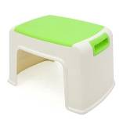 | 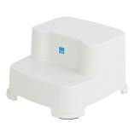
Shapes | 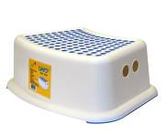 | 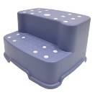
Shapes | 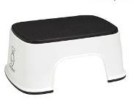 | 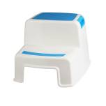
↲
The step was divided into 1-level and 2-level steps depending on it form. Infants and young children can choose to use either of the two depending on their height and use environment, and since the place of use is mostly bathroom, product using a slide prevention pad was the most common. 1-level step was mostly used adulst and elders as a low support, rather than short infants and young children. On the other hand, since the 2-level step is taller than 1-level step, short infants and young children are the main users and it is used by various places such as the bathroom, living room, and veranda.
↲
TABLE Ⅲ

Category | All-in-one | Separated
Functions | 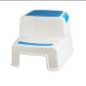 | 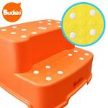
Functions | 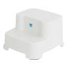 | 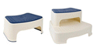
↲
The functions of a step can be divided into an all-in-one type and separated-type. The all-in-one type is cheaper and lighter than the separated-type, so it is more convenient to be carried. The separated-type has various functions, such as a slide prevention pad that can be combined to the main body of all-in-one step. It means that a slide prevention pad can be attached to the step when it is used in a bathroom and can be separated when it is used in a relatively safe place. In addition, as a product that can separate/combine the 1st level and 2nd levels, the two levels can be purchased individually. The two levels can be used combined to be high for short infants and young children during their growth, and once they have grown to a some degree the 1st and 2nd levels can be separated to fit the height of users in a certain product. This is also related to the company’s productivity. An all-in-one step has a lower unit cost to produce than characteristic products such as the separated-type step, but has no differentiating elements from other products so it is difficult to satisfy purchasers’ needs. However, characteristic steps like the separated-type have a high production cost so they are expensive, but unlike other products it has differentiating elements and satisfy purchasers’ needs.

TABLE Ⅳ

Category | Character | Non-character
function | 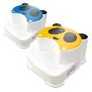 | 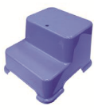
function | 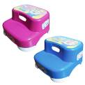 | 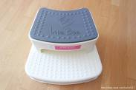
function | 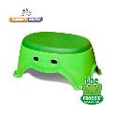 | 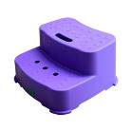
↲
The design of a step can be divided into a character and non-character type. A character step draws infants and young children’s attention as a more accessible design. On the other hand, a non-character step only has a company’s logo inscribed to promote the producing company or only makes its form.

C. Analysis of Users and Purchasers

The results of the step market research showed that bathroom was the most common place of use. Since a step has different users (infants and young children) and purchasers (housewives), the video of infants and young children using the step was analyzed and an in-depth interview and survey questionnaire were conducted to analyze the needs and wants of purchasers so that the use environment can be analyzed. First, the actual video of infants and young children using the step was analyzed for identifying the problems of the existing step, on April 17, 2017 in 5 households. The information of video observing the use of the existing step is as in <Figure 1>.

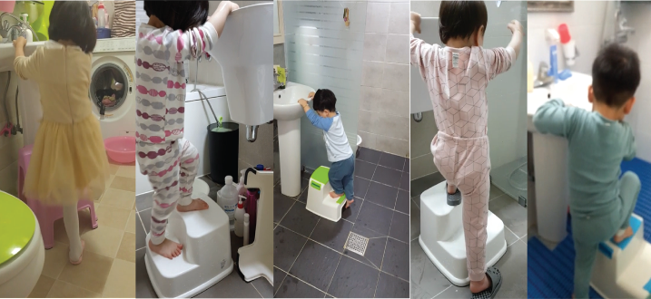

Fig. 1 Analysis of user videos

The observation of the video of children using the existing step showed that short infants and young children grabbed the sink to climb up the step so that they would not fall down in the slippery bathroom. In fact, the existing step had 4 short pads on 4 edges to prevent sliding or thin, long pads on two sides only so children could easily slip off. This observation showed that a new step design for infants and young children could be directed to a product emphasizing on slide prevention for their safety. Also, to collect information from the purchasers of step, an in-depth interview was carried out. To make a step with differentiating factors, individual interviews were carried out on 13 housewives whose children were using a step for 5 days from January 2, 2017 to 6, 2017. The purpose of the interviews was to find the usage of the existing step, its place of use, use environment, problems, etc. as in <Table 5>.
↲
TABLE Ⅴ

Category | Type | Usage | Place  and storing | Size  and height
1 | 1-level | Sink + toilet | Toilet | Unsatisfied
2 | 1-level | Sink + toilet | Living room | Unsatisfied
3 | 1-level | Sink | Sink | Unsatisfied
4 | 2-level | Sink | Sink | Satisfied
5 | 2-level | Sink | Sink | Satisfied
6 | 2-level | Sink | Sink | Satisfied
7 | 2-level | Sink | Bathroom | Satisfied
8 | 2-level | Sink | Bathroom | Satisfied
9 | 2-level | Sink | Bathroom | Satisfied
10 | 2-level | Sink + toilet | Bathroom | Satisfied
11 | 2-level | Sink | Bathroom | Satisfied
12 | 2-level | Sink | Bathroom | Satisfied
13 | 2-level | Sink | Bathroom | Satisfied
Other opinions
1. Prevents water stain
2. Prevents slide
3. Free use (separation) of 1-level and 2-level steps
4. Monotonous step form
↲
The purchasers of the existing step expressed various opinions on the step they were using as a product to develop their children’s safety and independence. Housewies who bought the 1-level step were mostly dissatisfied with the height and wished they could separate the 1st and 2nd levels for both children and adults to use the step. They also had most worries over sliding due to small size and height. On the other hand, the purchasers of 2-level step were mostly concerned with water stain due to the huge size and tall height.

D. Results of User and Purchaser Analysis

The parts of improvements, acceptance, and possibilities of development of the existing step were analyzed based on the opinions of users – infants and young children and purchaser – housewives.
First, the main space of use was bathroom and the main users were infants and young children, so a step still arouses safety anxiety even though there are guardians around. It is a product that helps and cultivates self-reliance for short infants and young children, but its sliding problems have led to the necessity of improvements. Second, purchasers use and purchase a step. Their most common desire for the existing step was to have a step that can separate the 1st and 2nd levels to have more design differentiation and use convenience. Above all, they mostly expressed concerns over improving water stain.
Third, regarding the step height and size, both purchasers and users were dissatisfied with the height and size of 1-level step, while young children and purchasers of the 2-level step were satisfied with its size and height. This showed that 2-level step had a higher preference, as it was consistent with the results of the search preference research and purchase preference of 1-level and 2-level step in the previous market research. In response, this study developed a design concept with a focus on better safety (slide prevention), product management and form since the users of step are infants and young children, although it is a produt complementing users’ height.

III. Design

A. Setting of Design Concept

This study designed a concept to improve problems drawn from market research and user/purchaser analysis as in <Figure 2>.
↲
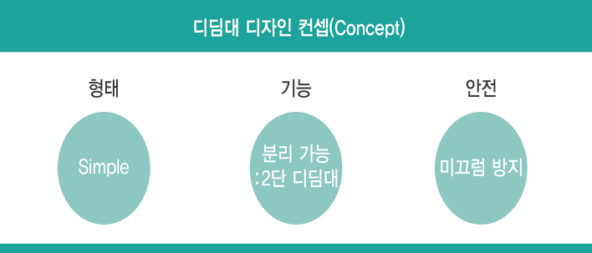
Prevents slide
Separable: 2-level step
Form Function Safety
Design concept of steps

Fig. 2 Design concept of steps

This study designed a step in 3 design concepts: form, function, and safety. The detailed explanations of the design concepts are as follows. First, the design eliminated unnecessary elements and pursued a simple design with only necessary elements. Second, it provided user convenience for their various use according to height and places by making the 1st and 2nd levels separable. Third, the design aimed to improve slide prevention for the safety of infants and young children, who are the main users, and alleviate the concerns over water stain, a problem stressed by purchasers.

B. Design Proposal

Idea sketch was carried out based on the 3 concepts set above, especially to remove unnecessary functions and forms as much as possible and to differentiate from existing steps in the market with separable 1-level and 2-levels

TABLE Ⅵ

Category | Sketch
New step | 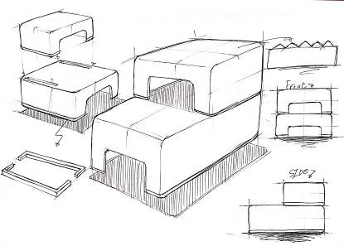

The step developed in this study added safety by inserting a slide prevention pad below 1-level and 2-level steps. Also, while the existing step uses a slide prevention pad by making the lower part wide and arched, the step developed in this study was designed in a neat form by eliminating unnecessary curves.

C. Development of Design

The design developed through idea sketch is 3D modeling and rendering in <Figure 3> below.
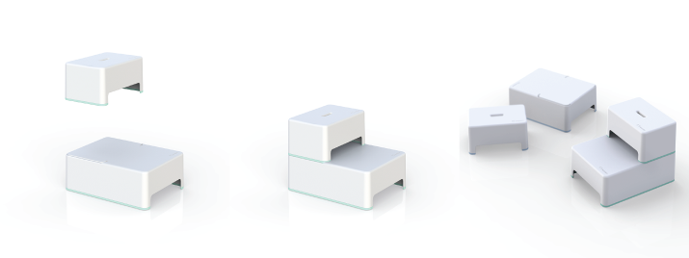

Fig. 3: 1st design development

For the primary design development, modeling and rendering were carried out focusing on the step form. It excluded an unnecessary form, emphasized on practical and functional sides, made the 1st and 2nd levels separable, and designed the main body in a stair form for children to climb safely. Also, unlike the existing step, the slide prevention pad on the bottom was made and sold in various colors for consumers to choose the color they want, thereby having differentiation from other products. After the primary design development, this study also performed an in-depth interview with purchasers and made the following additional revision on the design. <Figure 4> shows the features of differentiated design.

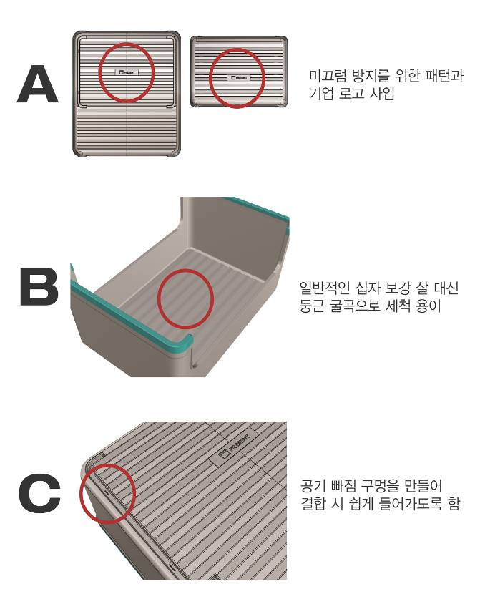
Air fall-out holes for easier insertion during setup

Easy to watch due to round curves insetad of regular cross stiffeners
Insertion of slide preventing patterns and company logo

Fig. 4: 2nd design development

First, to reduce the worries over water stain, the stiffener inside the existing product to increase its durability was decided to be removed. Since the product durability may weakene once the stifferener is removed, the product was made to be thicker in the design development. Second, air fall-out holes were created in the cracks of the lower step for the 1st and 2nd levels to go in more easily when they are combined. Third, the company’s logo was decided to be carved on the outside of the step to highlight the premium brand image.

D. Prototype Production

A prototype was made for the design from the 1st and 2nd design developments.
↲
TABLE Ⅶ
Prototype (Mock-up)
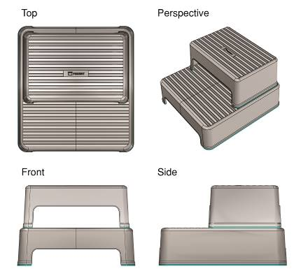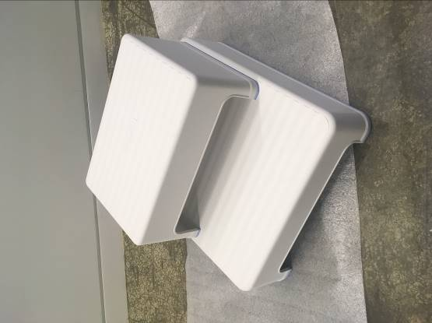

The design was revised more closely through a meeting on design development and 3-time interviews with purchasers after the prototype making. First, since it was pointed out that the durability may fall because the slide prevention pad of upper step was too high, the height of the slide prevention pad was lowered. Second, the foot-part on the upper step was narrowed a bit to increase durability and unity with lower step design.
↲
TABLE Ⅷ
Features
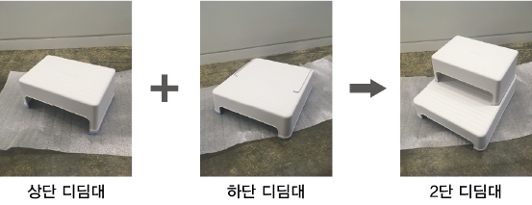
Upper step Lower step 2-level step

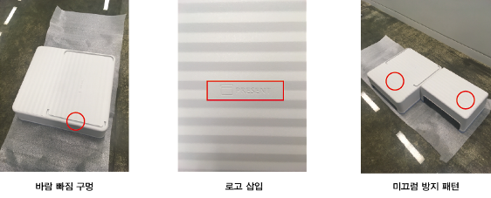
Wind fall-out hole Logo insertion Slide prevention pattern

↲
The characteristics of the final design result can be summarized as follows. First, the new product allows infants and young children to use it more safely with a simple form and wider slide prevention pattern than the existing product. Second, the area of the step floor touching the bathroom was made wider than the existing products, preventing the sliding of the floor more strongly. Third, the new step can be separated into 1st and 2nd levels, so a young child can only use the 1st step and the product can be used for a longer-term. The durability of the product was increased for adults to use it in a longer-term when necessary. Fourth, to minimize the issue of water stain that has been purchasers’ most concern after safety, the stiffener inside the product was removed. In addition, the form of the step product was made to maintain simplicity more. Most existing step products had a stiffener inside which would be stained by water easily. Fifth, wind fall-out holes were made to combine the 1st and 2nd steps more easily.

4. Conclusion

To satisfy all setps with different users and purchasers, it is necessary to develop a new step with an idea that is different from the existing step. Thus, this study proposed an idea for user’s safety and independence and direction for design. To develop a new step for children, this study conducted an online market research on the existing step products, observation of product use by users (infants and young children), and in-depth individual interviews with purchasers (housewives), thereby developing a new design concept. After the development of a new design concept, this study carried out idea sketch, modeling and rendering, primary design development, and secondary design development, and verified the developed design by making a prototype. The new step for children was thoroughly developed to be successful in the market, and several interviews with purchasers were carried out to increase the success of marketability. Although it is right to have interviews with uers, considering that users are young children for this study, the interviews were carried out on young children’s mothers who are the product purchasers and always watch the use environment. The results showed that the most important elements of a step were stability, preference on a separate type of 1st and 2nd steps, and little water stain. Thus, the new design was developed to reflect such needs and wants of purchaseers as much as possible.
The steped developed for children in this study had increased stability as a design with a wide area of bathroom floor and the application of slide prevention patterns. Second, this study applied the separate structure of 1st and 2nd levels. Third, the product had a simle design for easier washing of the inner part of product that has the most water stain. This study described the cases researched and developed for the company to launch a new product. When such empirical studies are aggregated, it is believed that trials and errors will be reduced through onsite design development cases in many industries and academias and more helpful information will be provided.

This research was supported by BK21plus Level-up Project for Marine design team in Dongseo University

References

[1] National Statistical Office Population Trend Division, Birth Statistics in 2016 (confirmed), National Statistical Office Report, p.5, August 2017
[2] Yong-seon Choi, “The Size of Baby Products rather Gew in the Era of Low Birthrate”, Energy Economy, july 2017

